**HR Management System**

Advanced Database Management System

**Submitted To**: REZWAN AHMED

**Section:** A

**Semester:** FALL 2018-2019

**Group Members:**

**NAME:** **ID:**

1. NAHID 16-3-2

2. NUSIBA 16-3-2

3. ISTIAQUE 16-3-2

4. MAZID-UL-HAQUE, MD. 16-32566-2

**Table of Contents**

**Introduction:**

**Human resource management** systems’ database is designed to manage payroll, attendance, leave management and staff personal information.

The aim of this project is to design such database which allows the admin to streamline their human resource tasks and manage their employee in a more effective and efficient way.

The system will ensure effective utilization and maximum development of human resource, generate and maintain human resource records and allow proper interactions and timely access to accurate information to those who require the information.

**System Summary:**

This database will be able to manage employee information by automating core HR, benefits and payroll processes for increased efficiency and productivity. It will also reduce the time of computation taken between process by timely generating the necessary reports and statistics. This database will reduce redundant data and error scope by easily creating accurate reporting and analysis. This database will ensure the security of employee information. The aim of creating such a database is to reduce routine administration and promote a paperless environment.

**Scenario Description:**

A **Human Resource Management System** database is a form of database that combines a number of processes to ensure the easy management of human resources, business processes and data. Human Resources Software is used by businesses to combine a number of necessary HR functions, such as storing employee data, managing payrolls, recruitment processes, benefits administration and keeping track of attendance records. It ensures everyday Human Resources processes are manageable and easy to access.

It merges human resources as a discipline and, in particular, it’s basic HR activities and processes with the information technology field. The linkage of its financial and human resource modules through one database is the most important distinction to the individually and proprietarily developed predecessors.

Human Resource Information Systems provide a means of acquiring, storing, analyzing and distributing information to various stakeholders. HRIS enable improvement in traditional processes and enhance strategic decision-making. The wave of technological advancement has revolutionized each and every space of life today, and HR in its entirety was not left untouched.

Early systems were narrow in scope, typically focused on a single task, such as improving the payroll process or tracking employees' work hours. This system covers the full spectrum of tasks associated with Human Resources departments, including tracking & improving process efficiency, managing organizational hierarchy, and simplifying financial transactions of all types.

**ER Diagram**

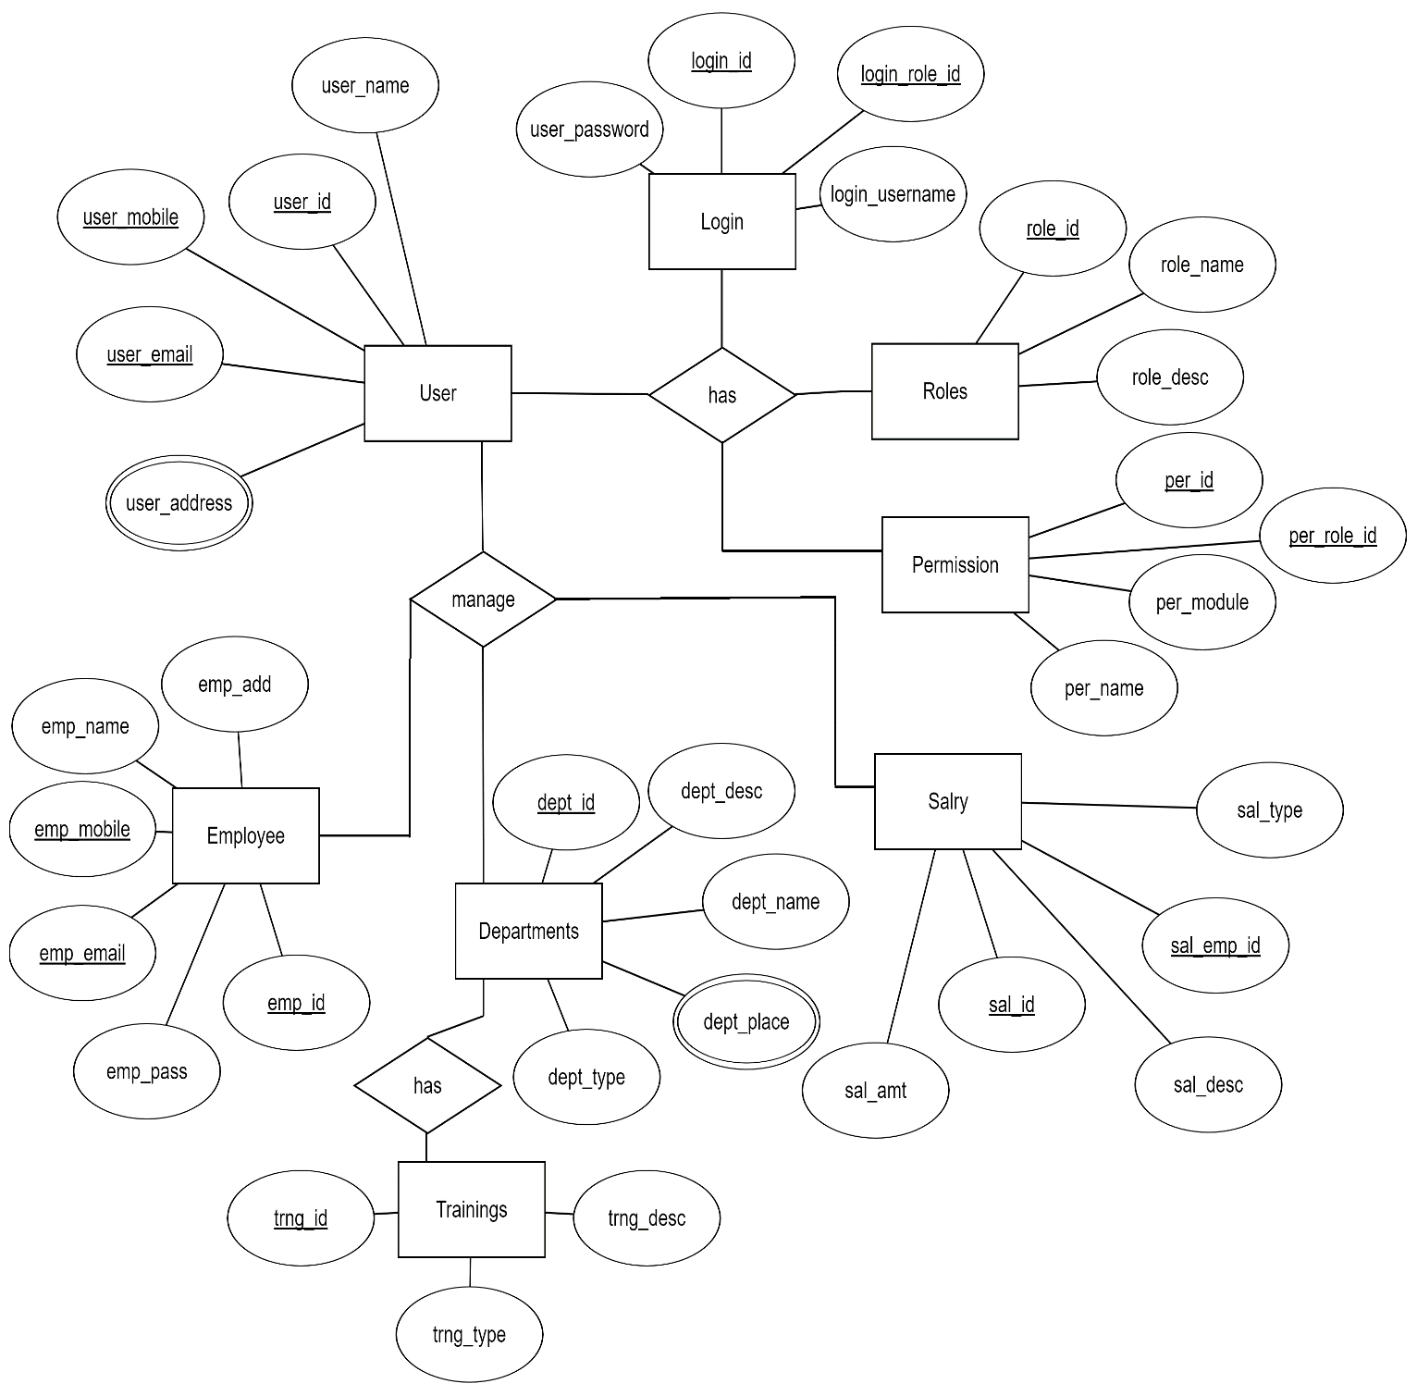

**CLASS, USECASE, ACTIVITY DIAGRAMNORMALIZATION**

* **Login_User**

**1NF**

|  |  |  |  |  |  |  |  |
| --- | --- | --- | --- | --- | --- | --- | --- |
| user_id | user_name | user_mobile | user_email | user_address | login_id | user_password | login_username |
|  |  |  |  |  |  |  |  |

**2NF**

**User_Info**

|  |  |  |  |  |
| --- | --- | --- | --- | --- |
| **user_id** | **user_name** | **user_mobile** | **user_email** | **user_address** |
|  |  |  |  |  |

**Login_Info**

|  |  |  |  |
| --- | --- | --- | --- |
| **login_id** | **user_id** | **login_username** | **user_password** |
|  |  |  |  |

* **Login_Role**

**1NF**

|  |  |  |  |  |  |
| --- | --- | --- | --- | --- | --- |
| **login_id** | **login_username** | **user_password** | **Role_id** | **Role_name** | **Role_desc** |
|  |  |  |  |  |  |

**2NF**

**Login_Info**

|  |  |  |  |
| --- | --- | --- | --- |
| **login_id** | **role_id** | **login_username** | **user_password** |
|  |  |  |  |

**Roles_Info**

|  |  |  |
| --- | --- | --- |
| **role_id** | **role_name** | **role_desc** |
|  |  |  |

* **Role_Permission**

**1NF**

|  |  |  |  |  |  |
| --- | --- | --- | --- | --- | --- |
| **role_id** | **Role_name** | **Role_desc** | **per_id** | **per_name** | **Per_module** |
|  |  |  |  |  |  |

**2NF**

**Permission_Info**

|  |  |  |  |
| --- | --- | --- | --- |
| **per_id** | **role_id** | **per_name** | **per_module** |
|  |  |  |  |

**Roles_Info**

|  |  |  |
| --- | --- | --- |
| **role_id** | **role_name** | **role_desc** |
|  |  |  |

* **Employee_Departments**

**1NF**

|  |  |  |  |  |  |  |  |  |  |  |
| --- | --- | --- | --- | --- | --- | --- | --- | --- | --- | --- |
| **emp_id** | **emp_pass** | **emp_email** | **emp_mobile** | **emp_name** | **emp_add** | **dept_id** | **dept_desc** | **dept_name** | **dept_place** | **dept_type** |
|  |  |  |  |  |  |  |  |  |  |  |

**2NF**

**Employee_INFO**

|  |  |  |  |  |  |  |
| --- | --- | --- | --- | --- | --- | --- |
| **emp_id** | **emp_pass** | **emp_email** | **emp_mobile** | **emp_name** | **emp_add** | **dept_id** |
|  |  |  |  |  |  |  |

* **Department_Info**

|  |  |  |  |  |
| --- | --- | --- | --- | --- |
| **dept_id** | **dept_desc** | **dept_name** | **dept_place** | **dept_type** |
|  |  |  |  |  |

* **Departments_Trainings**

**1NF**

|  |  |  |  |  |  |  |  |
| --- | --- | --- | --- | --- | --- | --- | --- |
| **dept_id** | **dept_desc** | **dept_name** | **dept_place** | **dept_type** | **trng_id** | **trng_desc** | **trng_type** |
|  |  |  |  |  |  |  |  |

**2NF**

**Department_Info**

|  |  |  |  |  |
| --- | --- | --- | --- | --- |
| **dept_id** | **dept_desc** | **dept_name** | **dept_place** | **dept_type** |
|  |  |  |  |  |

**Trainings_info**

|  |  |  |  |
| --- | --- | --- | --- |
| **trng_id** | **trng_desc** | **trng_type** | **dept_id** |
|  |  |  |  |

* **Employee_Salary**

**1NF**

|  |  |  |  |  |  |  |  |  |  |
| --- | --- | --- | --- | --- | --- | --- | --- | --- | --- |
| **emp_id** | **emp_pass** | **emp_email** | **emp_mobile** | **emp_name** | **emp_add** | **sal_id** | **sal_amt** | **sal_desc** | **sal_type** |
|  |  |  |  |  |  |  |  |  |  |

**2NF**

**Employee_INFO**

|  |  |  |  |  |  |
| --- | --- | --- | --- | --- | --- |
| **emp_id** | **emp_pass** | **emp_email** | **emp_mobile** | **emp_name** | **emp_add** |
|  |  |  |  |  |  |

**Sal_Info**

|  |  |  |  |  |
| --- | --- | --- | --- | --- |
| **sal_id** | **emp_id** | **sal_amt** | **sal_desc** | **sal_type** |
|  |  |  |  |  |

**Schema Diagram**

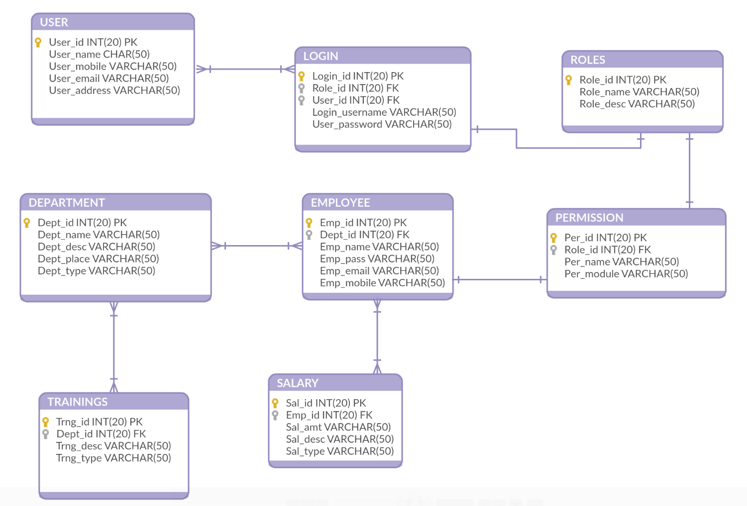

**Table creation**

**Table creation(**Adding Foreign Key**)**

**DATA INSERTION**

**User_Info**

**Roles_Info**

**Department_Info**

**Login_Info**

**Permission_Info**

**Employee_Info**

**Trainings_Info**

**Sal_Info**

**DML OPERATIONS TO DEMONSTRATE SOME DATABASE USE SCENARIOS**

**Conclusion:**

This project was done as a part of Midterm project for Advanced Database Management System. It was undertaken to plan, design and develop a Human Resource management system database.

This database allows user to manage employee information by automating core HR, benefits and payroll processes for increased efficiency and productivity. It also reduces the time of computation taken between process by timely generating the necessary reports and statistics. This database will be able to reduce redundant data and error scope by easily creating accurate reporting and analysis. This database will ensure the security of employee information. The aim of creating such a database is to reduce routine administration and promote a paperless environment.